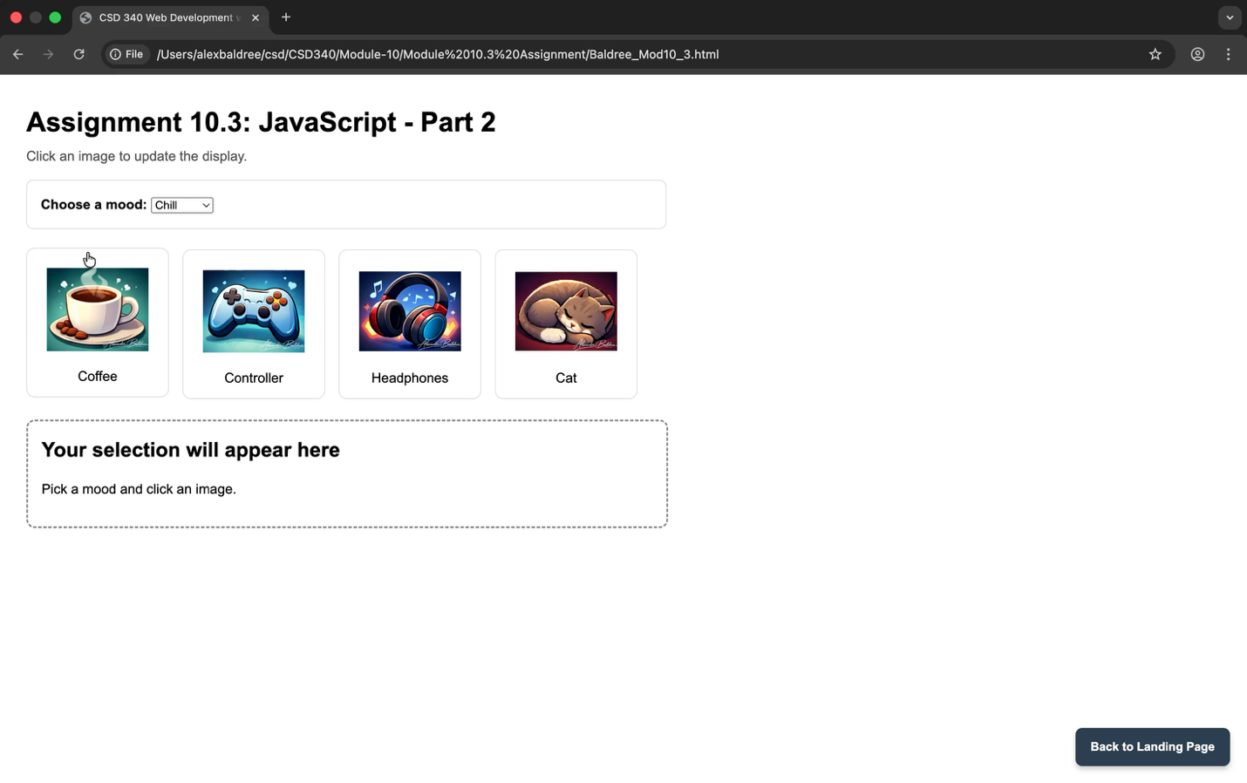
Alexander Baldree
03/06/26
Module 10.3 Assignment
CSD340

GitHub Link:
https://github.com/Panda-Alex21687/CSD340

Right Click and select Play- This is a video of the site in motion (instead of taking 16 screenshots)

